Temasek Polytechnic
School of Informatics and IT

Diploma in Information Technology (IT)

Software Design Specifications (DS)

Project Particulars

Tutor | Qi YuTao
Class | P04
Project Title | Hotel Management System

Project Team’s Particulars

Matric Number | Student Name
1704144C | Muhammad Ismail Bin Mohamed Ibrahim
1702625C | Soo Yuan
1703208G | Berwin Leong
1700803H | Ting Chao Chong

Revision History

Date | Version | Description | Author
<2/1/2019> | <1.0> | Do architecture design and User Interface | <Ismail and Chao Chong>
<3/1/2019> | <2.0> | Do Program Design and Database Design | <Soo Yuan and Berwin>
<4/1/2019> | <3.0> | Check architecture design and User Interface | <Soo Yuan and Berwin>
<5/1/2019> | <4.0> | Check program Design and Database Design | <Ismail and Chao Chong>

Table of Contents

1. DISTRIBUTION OF WORKLOAD 4
2. ARCHITECTURE DESIGN 4
3. USER INTERFACE (UI) DESIGN 4
4. PROGRAM DESIGN 4
5. DATABASE DESIGN 4

DISTRIBUTION OF WORKLOAD

Design | Members
Architecture Design | Muhammad Ismail Bin Mohamed Ibrahim
Program Design | Soo Yuan
Database Design | Berwin Leong
User Interface | Ting Chao Chong

ARCHITECTURE DESIGN

A 30-tier architecture is basically a type of software which has 3 layers of logical computing. They often use it in applications such as Servers. 3-tiers architectures will provide a lot of benefits including production and developing environmental user interface, business logic or data storage layers. By allowing this, this will enhance flexibility to the development teams as they will only need to update a specific part of the applications instead of the whole application. This will improve the company time-to-market and decrease the amount of time needed for the developing team to update, replace or upgrade the tiers without affecting the other parts of the system.

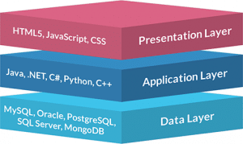

The Three Tiers are Presentation Tier, Application Tier and Data Tier

Presentation Tier

This is basically the front end of the 3 tiers and will consists of the user interface. This user interface is often an interface accessible through a web browser which can display content to an end user. This tier is often made by HTML 5. Java Script or CSS through API calls

Application Tier

This Tier contains the functions needed to run the application. This is often written in Java, .NET, C#, Python, C++ and many others more.

Data Tier

This Tier contains the database and data access layer. Example of this will be MySQL, Oracle, MongoDB and more. This Data is accessed by API Calls

Benefits of Using A 3-Tier Architecture

The benefits include the speed of development, scalability, performance and availability. By having disparate layers, the company can also increase reliability and availability as the company can host different parts of the application on different servers and utilizing the cached available. By using 3 tier systems the company do not have to worry about the server crashing or affecting the performance throughout the whole system as the it is 3 physical parts this will minimize performance issues when a server goes down.

USER INTERFACE (UI) DESIGN
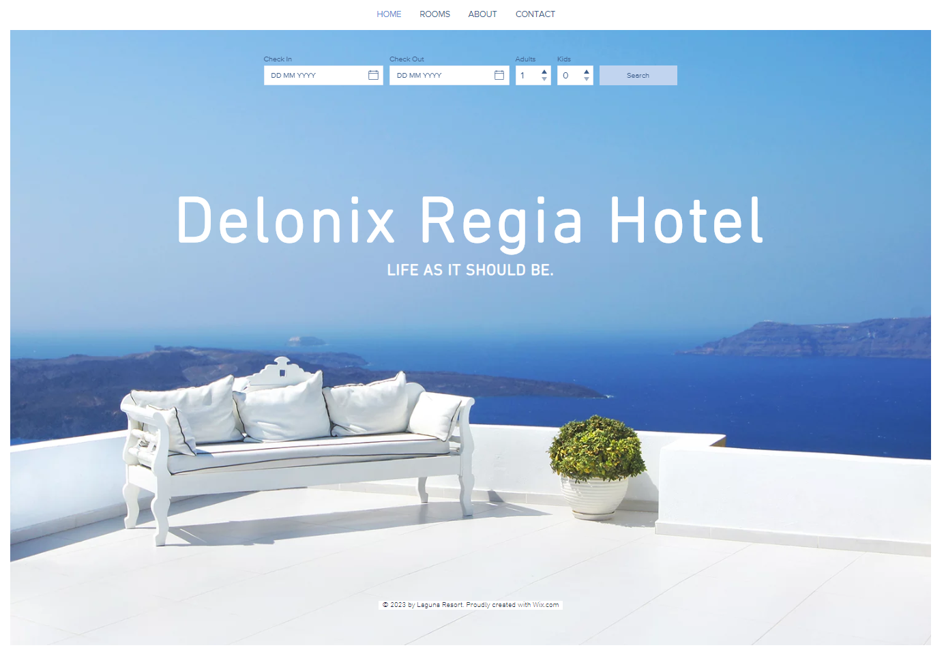
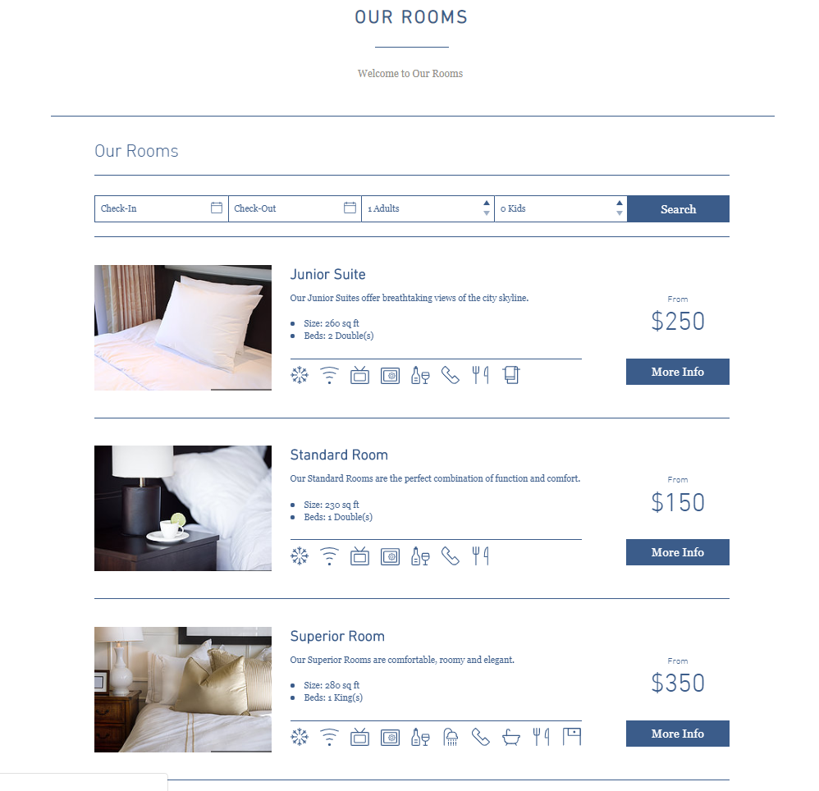
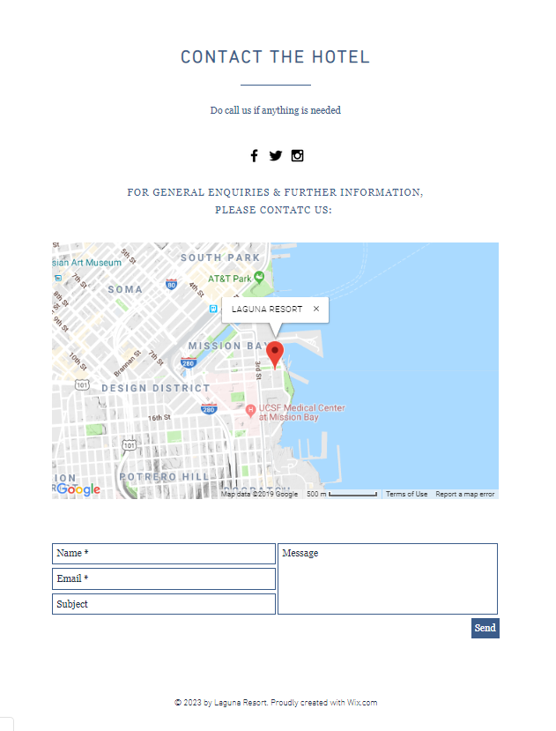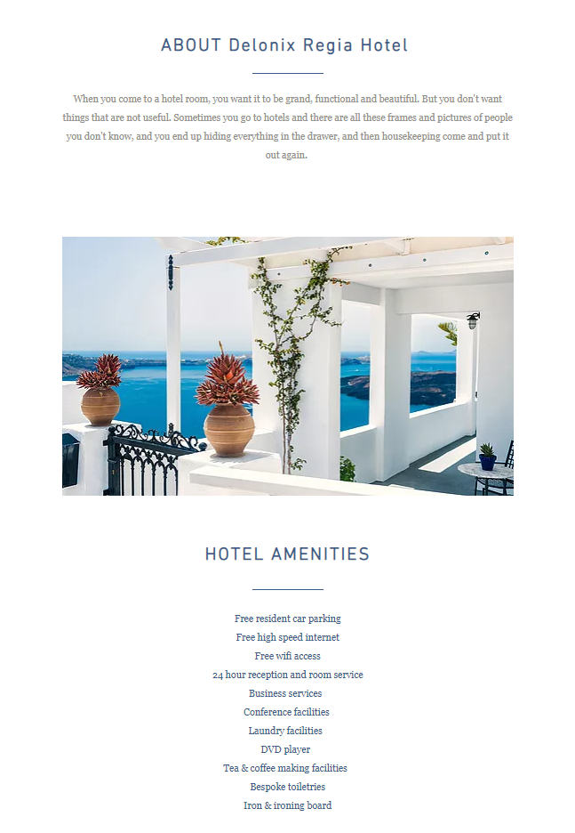

Program Design

Main flow – User booking available room

User access website

User creates account with email and logs in

User selects option to view available rooms

User selects desired room

User keys in credit card information

User adds additional remarks

Invoice sends to user email

Main flow ends

Alternate Flow – User wishes to book room, but type of room is unavailable

User access website

User creates account with email and logs in

User selects option to view all rooms

User selects desired room, but room is currently in use, unavailable

Website displays date where room will be available for selection

User books the room on selected timing

Alternate flow ends

DATABASE DESIGN

Guest table

Field Name | Data type | Field Size | Primary / Foreign Key | Nullable | Unique | Description | Example
Guest_id | INT | 1 | PK | No | Yes | Id of guest | 1
guestName | VARCHAR | 50 | PK | No | Yes | Name of guest | John
guestMobile | VARCHAR | 8 | PK | No | Yes | Guest mobile number | 12345678
guestEmail | VARCHAR | 30 | PK | No | Yes | Email of guest | qwerty@gmail.com
guestAddress | VARCHAR | 10 | PK | NO | YES | Address of guest | Temasek polytechnic
Creditcard_id | VARCHAR | 16 | FK | NO | yes | Guest credit card id | 12345678  12345678
checkinDate | DATE | - | PK | NO | No | Date of checkin | 04 – jan – 2019
checkinTime | TIME | - | PK | NO | yes | Time of checkin | 2359
additionalDetails | VARCHAR | 500 | PK | NO | YES | Additional remarks | King sized bed

Staff table

Field Name | Data type | Field Size | Primary / Foreign Key | Nullable | Unique | Description | Example
Staff_id | INT | 1 | PK | No | Yes | Id of staff | 1
staffName | VARCHAR | 30 | PK | No | Yes | Name of staff | Bob
staffDOB | VARCHAR | 6 | PK | No | Yes | Date of birth of staff | 12 – 12 - 00
bankAccountNumber | VARCHAR | 12 | PK | No | Yes | Bank account number of staff | 12345676712
staffAddress | VARCHAR | 50 | PK | NO | YES | Staff address | Temasek polytechnic
staffJobscope | VARCHAR | 30 | PK | NO | YES | Description of staff job | Cleaning
staffMobile | VARCHAR | 8 | PK | NO | YES | Mobile number | 12345678

